**UML Diagram**

1. **Behavioural diagram**

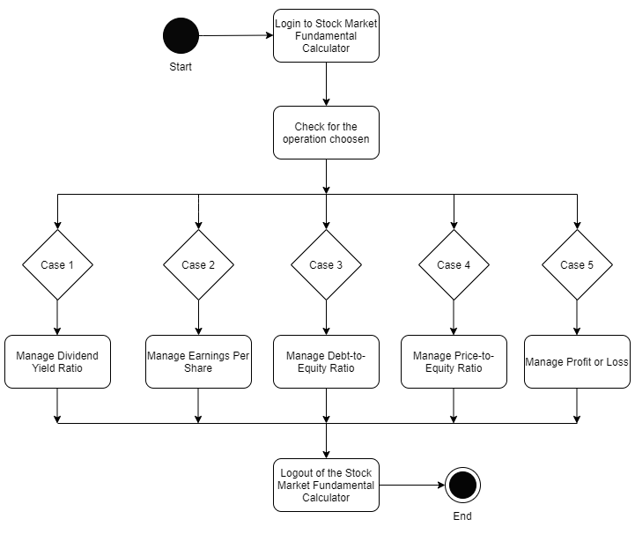

Fig 1: Activity diagram of Stock Market Fundamental Analyzer

**Description**

Stock market fundamental analyzer is a type of application which calculates the fundamental financial ratios based on the basic information such as net income of the company, market value of the share, etc. which is easily available in the balance sheet provided by the company.

There are five important things to be considered before deciding to invest in any company:

1. Dividend Yield Ratio
2. Earnings Per Share (EPS)
3. Debt-to-Equity Ratio
4. Price-to-Earnings Ratio
5. Profit or Loss

The proposed system will make use of basic information to calculate the above given important financial ratios to help newbies gain knowledge and profit in the share market.

The basic information needed are:

1. Cash dividend per share and face value of the share to find the Dividend Yield Ratio.
2. Net income and outstanding common shares of the company to find the Earnings per Share.
3. Total liabilities and total shareholders’ equity to calculate the Debt-to-Equity Ratio.
4. Market value and the EPS are required to find the Price-to-Earnings Ratio.
5. Buy price, sell price and quantity are required to calculate the Profit or Loss incurred by the users.